AI Assignment-06

Jeetu Mehra
U24AI032

Question 1: Use the city map given in Q1 of assignment 1 and implement the greedy best first search
and A* algorithm to reach Boston city from Chicago and compare your results in terms of the
number of cities explored before reaching your destination. Consider the heuristic values as
given below,
City h(n) to Boston
(miles)
Boston 0
Providence 50
Portland 107
New York 215
Philadelphia 270
Baltimore 360
Syracuse 260
Buffalo 400
Pittsburgh 470
Cleveland 550
Columbus 640
Detroit 610
Indianapolis 780
Chicago 860

Code:
import heapq

# Heuristic values h(n) to Boston
heuristic = {
"Boston": 0,
"Providence": 50,
"Portland": 107,
"New York": 215,
"Philadelphia": 270,
"Baltimore": 360,
"Syracuse": 260,
"Buffalo": 400,
"Pittsburgh": 470,
"Cleveland": 550,
"Columbus": 640,
"Detroit": 610,
"Indianapolis": 780,
"Chicago": 860
}

# City List (order matters for adjacency matrix)
cities = [
"Chicago", "Indianapolis", "Columbus", "Detroit", "Cleveland",
"Pittsburgh", "Buffalo", "Syracuse", "Philadelphia",
"Baltimore", "New York", "Providence", "Boston", "Portland"
]

n = len(cities)

# Mapping city -> index
index = {city: i for i, city in enumerate(cities)}

# Initialize adjacency matrix with infinity
INF = float('inf')
adj_matrix = [[INF] * n for _ in range(n)]

# Distance from node to itself = 0
for i in range(n):
adj_matrix[i][i] = 0

# Function to add undirected edges in matrix
def add_edge(u, v, cost):
i, j = index[u], index[v]
adj_matrix[i][j] = cost
adj_matrix[j][i] = cost

# -----------------------------
# Add edges based on given map
# -----------------------------
add_edge("Chicago", "Detroit", 283)
add_edge("Chicago", "Cleveland", 345)
add_edge("Chicago", "Indianapolis", 182)

add_edge("Indianapolis", "Columbus", 176)

add_edge("Columbus", "Cleveland", 144)
add_edge("Columbus", "Pittsburgh", 185)

add_edge("Detroit", "Cleveland", 169)
add_edge("Detroit", "Buffalo", 256)

add_edge("Cleveland", "Buffalo", 189)
add_edge("Cleveland", "Pittsburgh", 134)

add_edge("Buffalo", "Syracuse", 150)
add_edge("Buffalo", "Pittsburgh", 215)

add_edge("Pittsburgh", "Philadelphia", 305)
add_edge("Pittsburgh", "Baltimore", 247)

add_edge("Baltimore", "Philadelphia", 101)

add_edge("Philadelphia", "New York", 97)
add_edge("Philadelphia", "Syracuse", 253)

add_edge("Syracuse", "Boston", 312)
add_edge("Syracuse", "New York", 254)

add_edge("New York", "Boston", 215)
add_edge("New York", "Providence", 181)

add_edge("Providence", "Boston", 50)

add_edge("Boston", "Portland", 107)

# -------------------------------
# Get neighbors from adjacency matrix
# -------------------------------
def get_neighbors(city):
neighbors = []
i = index[city]
for j in range(n):
if adj_matrix[i][j] != INF and i != j:
neighbors.append((cities[j], adj_matrix[i][j]))
return neighbors

# -------------------------------
# Greedy Best First Search
# -------------------------------
def greedy_best_first(start, goal):
pq = []
heapq.heappush(pq, (heuristic[start], start))

visited = set()
parent = {}
explored_order = []

while pq:
h, node = heapq.heappop(pq)

if node in visited:
continue

visited.add(node)
explored_order.append(node)

if node == goal:
break

for neighbor, cost in get_neighbors(node):
if neighbor not in visited:
if neighbor not in parent:
parent[neighbor] = node
heapq.heappush(pq, (heuristic[neighbor], neighbor))

# Reconstruct path
path = []
cur = goal
while cur != start:
path.append(cur)
cur = parent.get(cur)
if cur is None:
return None, explored_order
path.append(start)
path.reverse()

return path, explored_order

# -------------------------------
# A* Search Algorithm
# -------------------------------
def a_star(start, goal):
pq = []
heapq.heappush(pq, (heuristic[start], 0, start)) # (f, g, node)

visited = set()
parent = {}
g_cost = {start: 0}
explored_order = []

while pq:
f, g, node = heapq.heappop(pq)

if node in visited:
continue

visited.add(node)
explored_order.append(node)

if node == goal:
break

for neighbor, cost in get_neighbors(node):
new_g = g + cost

if neighbor not in g_cost or new_g < g_cost[neighbor]:
g_cost[neighbor] = new_g
parent[neighbor] = node
new_f = new_g + heuristic[neighbor]
heapq.heappush(pq, (new_f, new_g, neighbor))

# Reconstruct path
path = []
cur = goal
while cur != start:
path.append(cur)
cur = parent.get(cur)
if cur is None:
return None, explored_order, None
path.append(start)
path.reverse()

return path, explored_order, g_cost[goal]

# -------------------------------
# MAIN EXECUTION
# -------------------------------
start_city = "Chicago"
goal_city = "Boston"

greedy_path, greedy_explored = greedy_best_first(start_city, goal_city)
astar_path, astar_explored, astar_cost = a_star(start_city, goal_city)

print("========== ADJACENCY MATRIX ==========")
print("Cities order:", cities)
print("\nMatrix:")
for row in adj_matrix:
print(row)

print("\n========== GREEDY BEST FIRST SEARCH ==========")
print("Path:", greedy_path)
print("Cities explored order:", greedy_explored)
print("Total cities explored:", len(greedy_explored))

print("\n========== A* SEARCH ==========")
print("Path:", astar_path)
print("Cities explored order:", astar_explored)
print("Total cities explored:", len(astar_explored))
print("Total path cost:", astar_cost)

print("\n========== COMPARISON ==========")
print("Greedy explored:", len(greedy_explored))
print("A* explored:", len(astar_explored))

Output:
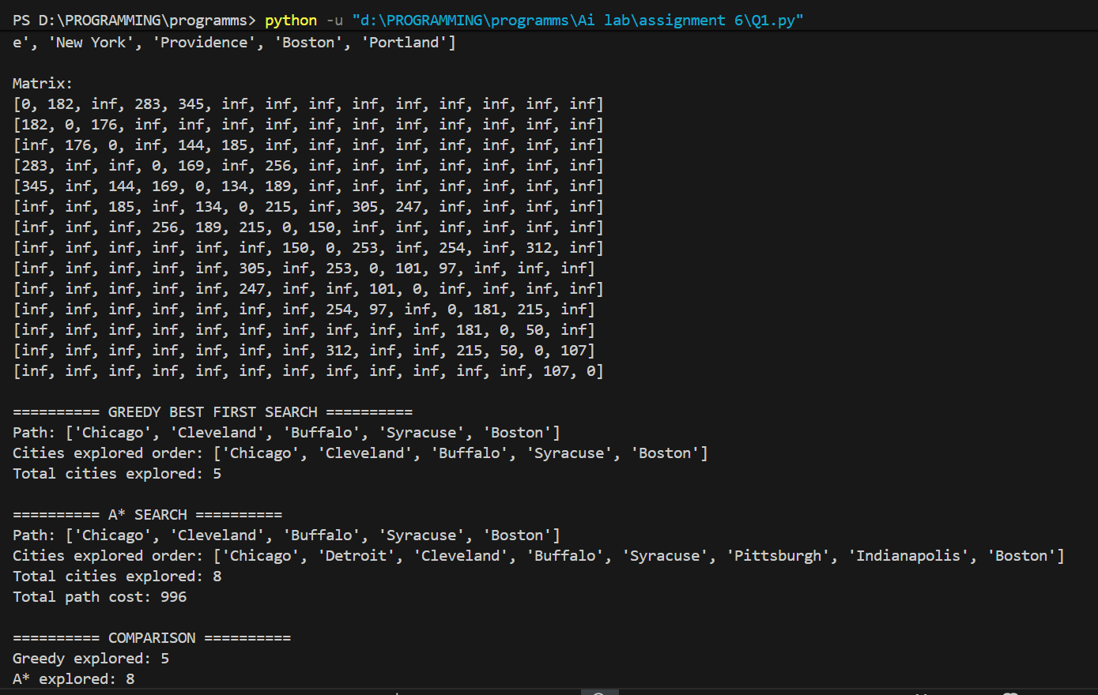

Question 2 : Consider a maze as a 5x5 matrix input where 0 denotes an empty tile, 1 denotes an
obstruction/wall, 2 denotes the start state and 3 denotes the reward. Assume valid actions as
L,R,U,D where L=move_left, R=move_right, U=move_up, D=move_down,. Use the A* algorithm
on the resultant maze for your agent to reach all the rewards, and keep a record of the tiles
visited on the way. Consider the rewards as goals. If all goals are completed, then one can
come out of the maze. Assume heuristic cost and evaluation cost with proper justification. 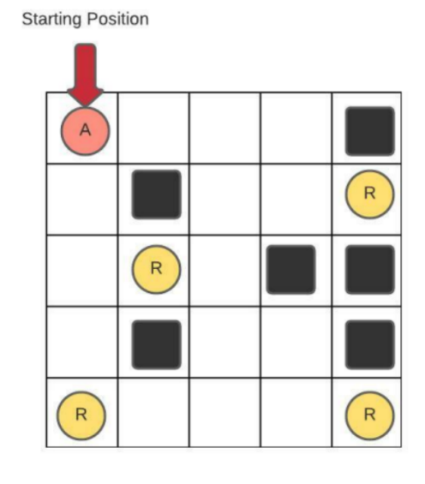
Code:
import heapq

# Value Meaning
# 0 Empty tile (you can move here)
# 1 Wall/obstruction (you cannot enter)
# 2 Start position (agent starts here)
# 3 Reward/Goal position (target points to collect)

maze = [
[2, 0, 0, 0, 1],
[0, 1, 0, 0, 3],
[0, 3, 0, 1, 1],
[0, 1, 0, 0, 1],
[3, 0, 0, 0, 3]
]

ROWS, COLS = 5, 5

# Directions: L, R, U, D
moves = {
"L": (0, -1),
"R": (0, 1),
"U": (-1, 0),
"D": (1, 0)
}

def manhattan(a, b):
return abs(a[0] - b[0]) + abs(a[1] - b[1])

def find_start_and_rewards(maze):
start = None
rewards = []
for r in range(ROWS):
for c in range(COLS):
if maze[r][c] == 2:
start = (r, c)
elif maze[r][c] == 3:
rewards.append((r, c))
return start, rewards

def a_star(start, goal):
pq = []
heapq.heappush(pq, (0 + manhattan(start, goal), 0, start))

parent = {}
g_cost = {start: 0}
visited_order = []

while pq:
f, g, current = heapq.heappop(pq)

if current in visited_order:
continue

visited_order.append(current)

if current == goal:
# reconstruct path
path = []
cur = goal
while cur != start:
path.append(cur)
cur = parent[cur]
path.append(start)
path.reverse()
return path, visited_order

for action, (dr, dc) in moves.items():
nr, nc = current[0] + dr, current[1] + dc

if 0 <= nr < ROWS and 0 <= nc < COLS and maze[nr][nc] != 1:
neighbor = (nr, nc)
new_g = g + 1

if neighbor not in g_cost or new_g < g_cost[neighbor]:
g_cost[neighbor] = new_g
parent[neighbor] = current
new_f = new_g + manhattan(neighbor, goal)
heapq.heappush(pq, (new_f, new_g, neighbor))

return None, visited_order

def collect_all_rewards():
start, rewards = find_start_and_rewards(maze)
current = start
collected = []
full_path = []
total_visited = []

while rewards:
# choose nearest reward (greedy selection of next goal)
rewards.sort(key=lambda x: manhattan(current, x))
goal = rewards[0]

path, visited = a_star(current, goal)

if path is None:
print("No path exists to reward:", goal)
return

# store results
full_path.extend(path[1:]) # avoid repeating same node
total_visited.extend(visited)

collected.append(goal)
rewards.remove(goal)
current = goal

print("Start:", start)
print("Rewards Collected in Order:", collected)
print("\nFinal Path Taken:")
print([start] + full_path)

print("\nTotal Tiles Visited During Searches:")
print(total_visited)

print("\nTotal Path Length:", len(full_path))

collect_all_rewards()

Output:
